***Eunotia paludosa* Grunow 1862, p. 336, pl. 3, fig. 10**

***Synonyms:*** *Eunotia denticulata* var. *fennica* Hustedt (1932: 291), *Eunotia fennica* (Hustedt 1932: 291) Lange-Bertalot (in Werum & Lange-Bertalot 2004: 152).

***Morphology***

Girdle view narrowly rectangular with slightly concave margins. Dorsal margin parallel or slightly to more strongly convex. Ventral margin distinctly concave. Apices short-protracted and more or less reflexed to the dorsal side. Terminal nodules close to the poles. Terminal raphe fissures in the valve face short. Striae almost parallel, equidistant throughout the entire valve. at the dorsal side of the mantle. Areolae difficult or not discernible in LM. Short spines on the dorsal side sometimes discernible, at least as tiny dark dots by focusing.

***Morphometrics***

| Source | Length (µm) | Width (µm) | Striae  (in 10 µm) | Areolae  (in 10 µm) |
| --- | --- | --- | --- | --- |
| Own data (n=21) | 27.5-50.0 | 3.7-4.7 | 17.4-20.5 |  |
| Van de Vijver et al. 2022 | 19-50 | 3.0-4.0 | 19-21 | 35-36 |
| Lange-Bertalot et al. 2017* | 16-65 | 3-5 | 15-22 | 32-35 |
| Lange-Bertalot et al. 2011* | 16-90 | 3-5 | 15-22 |  |
| Krammer & Lange-Bertalot 1997-2004* | 15-60(90) | (3)3,5-5 | 15-22 |  |
|  |  |  |  |  |
| *As *E. fennica* |  |  |  |  |

***Related species***

*Eunotia denticulata* s.s. (Brébisson ex Kützing) Rabenhorst 1864 (broader, less striae/10 µm, longer spines); *E. neoborealis* Lange-Bertalot(longer dorsal spines, broader on average (4-6.5 µm); *E. superpaludosa* Lange-Bertalot(dorsal margin less convex, spines lacking); *E. neocompacta* var. *vixcompacta* Lange-Bertalot (no spines)

***Distribution***

Scattered to moderately frequent in Central Europe. Langeveen, Poort II (NL).

***Ecology***

Undisturbed ombrotrophic peat bogs or dystrophic lakes with *Sphagnum*-association on the shores.

***Ecological values***

Indicator values (Mertens et al. 2025)

| **R** | **H** | **N** | **O** | **S** | **T** | **M** |
| --- | --- | --- | --- | --- | --- | --- |
| 2 | 1 | 1 | 1 | 1 | 1 | 4 |

IPS TDI

(Cemagref 1982) Rott et al.1997, 1999 (Kelly & Whitton 1995)

| **IPS-S** | **IPS-V** |  | **Rott SI s** | **Rott SI v** | **Rott TI s** | **Rott TI v** |  | **TI-S** | **TI-V** |
| --- | --- | --- | --- | --- | --- | --- | --- | --- | --- |
| 5 | 2 |  |  |  |  |  |  |  |  |



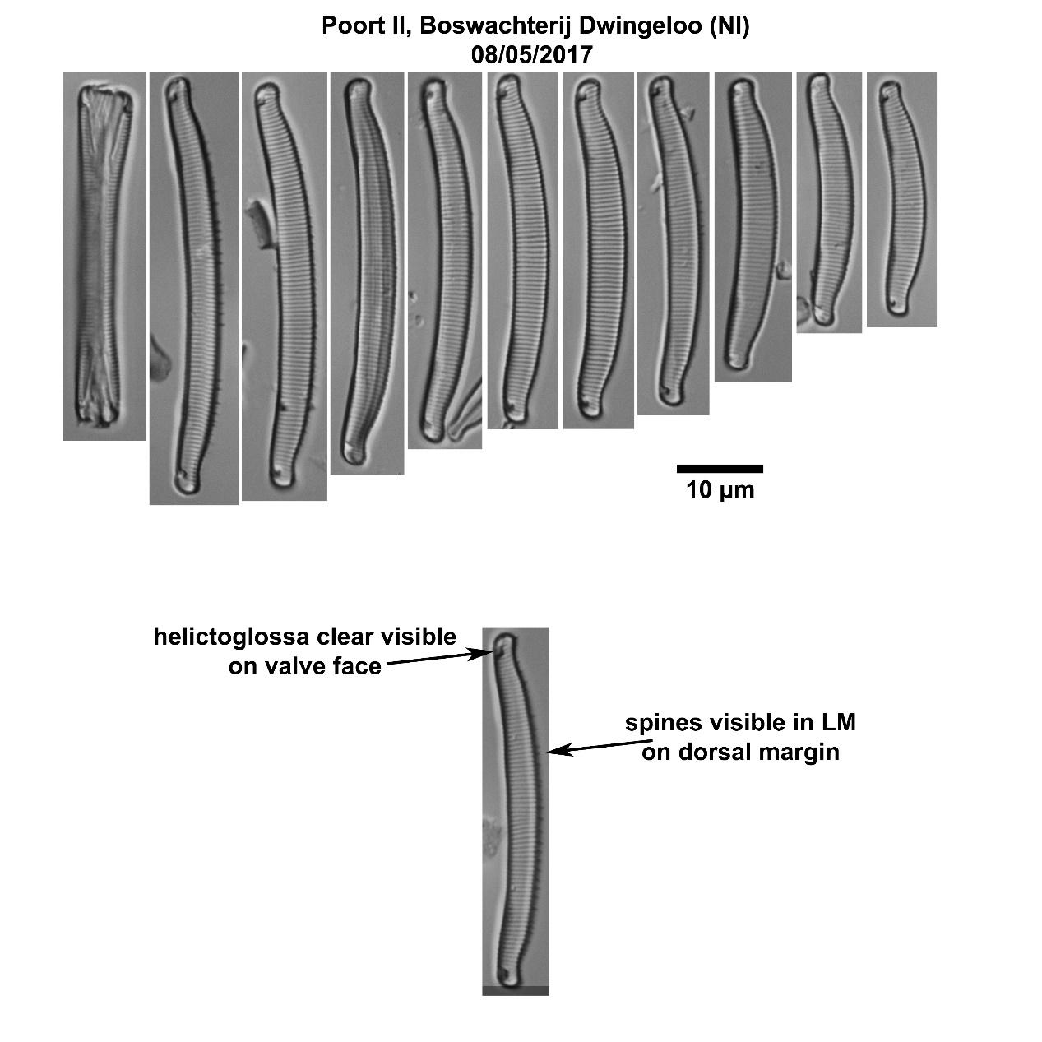

***References:***

Krammer, K. & H. Lange-Bertalot (1997-2004) Bacillariophyceae. Süßwasserflora von Mitteleuropa 2/1-4.

Lange-Bertalot, H., M. Bak & A. Witkowski (2011) *Eunotia* and some related genera. Diatoms of Europe: 6.

Lange-Bertalot, H., G. Hofmann, M. Werum & M. Cantonati (2017) Freshwater Benthic Diatoms of Central Europe.

Van de Vijver, B., H. Lange-Bertalot, C. Goeyers, A. Mertens, T.M. Schuster & L. Ector† (2022) The identity of *Eunotia paludosa* Grunow 1862 (Eunotiaceae, Bacillariophyta), a revision, and the description of three new species of *Eunotia* Ehrenberg.

***Citation:***

G.L. Verweij & A. Mertens, 2025, *Eunotia paludosa*. In Diatom Flora of the Low Countries. NVKD. Retrieved from <http://www.nvkd-diatom.nl/species>